# Assignment 7 – User Testing

Brett Bloethner | CSCI-E34

### Write a script describing an action that you want to test with a user of your mockup.

##### Tasks for story 1

* Enter the application
* Select a mockup from the mockup cards (mockup 1)
* Assign a developer to this mockup
* Assign a designer to this mockup
* Add some initial notes to this mockup
* Save the changes you made to the mockup (or notice an autosave)
* Get the shortlink for your saved mockup
* Copy the short link, allowing you to paste it into an agile web app of your choice
* Exit the mockup/app

##### Tasks for story 2

* Enter a mockup in the application via deep link
* View the info annotation & thread positioned on the “I’m Feeling Lucky” link on the mockup in the app
* Reply to this info annotation
* Save the reply (or notice an autosave)
* Exit the mockup/app

## Tasks for Story 3

* Enter a mockup in the application via deep link
* Create a new blocking annotation
* Position the annotation on the “Preferences” link on the mockup in the app
* Add a text description to your new blocking annotation
* Tag your teammate, Jim, in your annotation’s description
* Save the new blocking annotation (or notice an autosave)
* Exit the mockup/app

##### Tasks for story 4

* Enter the application
* Visit the settings menu
* Connect Slack to your account
* Configure Slack notifications so you’re notified when you’re assigned to a mockup
* Configure Slack notifications so you’re notified when a mockup you’re assigned to changes
* Configure Slack notifications so you’re notified know when you’re tagged in a mockup or when a mockup your tagged in changes
* Exit the mockup/app

### Using Balsamiq, modify your mockup to perform rudimentary operations described in your script

I used Balsamiq to create my initial mockups which I also used for the rudimentary prototypes that were used in this user testing. I created fairly simple user flows to let the user accomplish the tasks outlined in section one. Certain parts of the mockup such as adding text and dragging and dropping an annotation couldn’t be simulated by Balsamiq, so those UI elements were auto-filled/auto-placed for the user in testing. Two packages of story boards were created, each of which includes flows for all four user stories. The goal here was to give the user an opportunity to compare both and let us know what worked best between the two and where both may have fallen short.

**Storyboard 1:** HW7p1_UserTesting_BrettBloethner.bmpr

<https://app.box.com/s/8x1r9d752li5nbu51o8wtczps0ljtuie>

**Storyboard 2:** HW7p2_UserTesting_BrettBloethner.bmpr

<https://app.box.com/s/gs7lcyci97n6w1htkamxkb918ef2swso>

### Set up your test machine to record the screen session and audio when a test user tries your script

I used OSX’s built in screen capture tool In the OSX media player, QuickTime. This allowed me to capture the laptops screen and the room noise (AJ’s voice and mine) simultaneously. This proved to be pretty convenient since I didn’t need to install any extra software or trial software. I split the video into two parts. The first video includes the introduction and the user testing of the first storyboard. The second video includes the user testing of the second storyboard as well as the ending questions and short discussion. I then spliced a significant portion of each video to create an overall shorter summary video of the user test I conducted.

Storyboard 1 & Storyboard 2 User Test Snippet:

<https://www.youtube.com/watch?v=SsdBFWYopD0&feature=youtu.be>

### Recruit a user for your test. See how close you can come to your target persona. Describe to your TA how close you were able to get, how you would get close in a real life situation, and the kinds of incentives/bribes/threats that you required to secure the user’s services.

I was able to get the person I originally based my persona off of to participate as the user in this test. I think that could be considered as close to a match as you can get. Although, if I were to run more user tests I might try to get a little bit more of a diverse group of developers that still fit my persona. I think a slight variation in experience level and type of software engineering could potentially introduce some more diverse opinions on the apps features and UX. If I were to go back out and get more users to interview I think the easiest way to find them would be going to social events and meetups where developer’s hangout and offer them a Starbucks or Amazon gift card for a short user testing session on the spot or at a coffee shop sometime in the near future.

I was able to get AJ to agree to participate in my user test for nothing in return. However, to be nice and to be sure I got quality and unhurried responses, I bought him a few donuts from 7/11. We had plenty of time to conduct user testing in the office in the beginning of the day. It was really a frictionless task to get AJ to help with my user testing so I was pretty lucky in that respect.

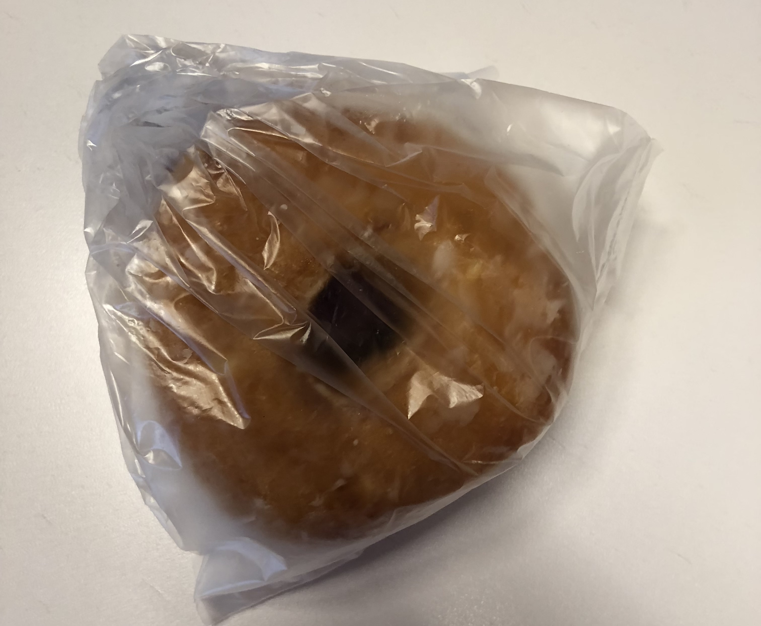

One Standard Glazed Donut from 7/11 (packaged for freshness)

Ideally, I think I would have conducted at least six user interviews in total with three of those being with individuals fitting my primary persona of a developer and three of them fitting my secondary persona of a designer. However, the designer user tests would require different tasks since the designer’s user stories differ slightly from the developer’s user stories.

### Sit the user down in front of your mockup. Read and introductory explanation to them, such as the one described in class. Then give him the assignment.

For my introductory script, I chose to use Steve Krug’s, Rocket Surgery Made Easy Usability test script. I filled it in with my project’s information, removed anything that wasn’t necessary, and made changes to anything that didn’t fit right out of the box. For my participant consent form I just used the University of California, Berkeley Visualization Lab “Usability test consent form.” I liked that the form was short, simple, and easy to understand. I also modified the copy in the usability test consent form to fit my user testing and project.

**Steve Krug’s, Rocket Surgery Made Easy Usability test script**

<http://sensible.com/downloads/test-script.pdf>

**University of California, Berkeley Visualization Lab “Usability test consent form“**

<http://vis.berkeley.edu/courses/cs160-sp12/wiki/images/e/e5/Group-omg-consent.pdf>

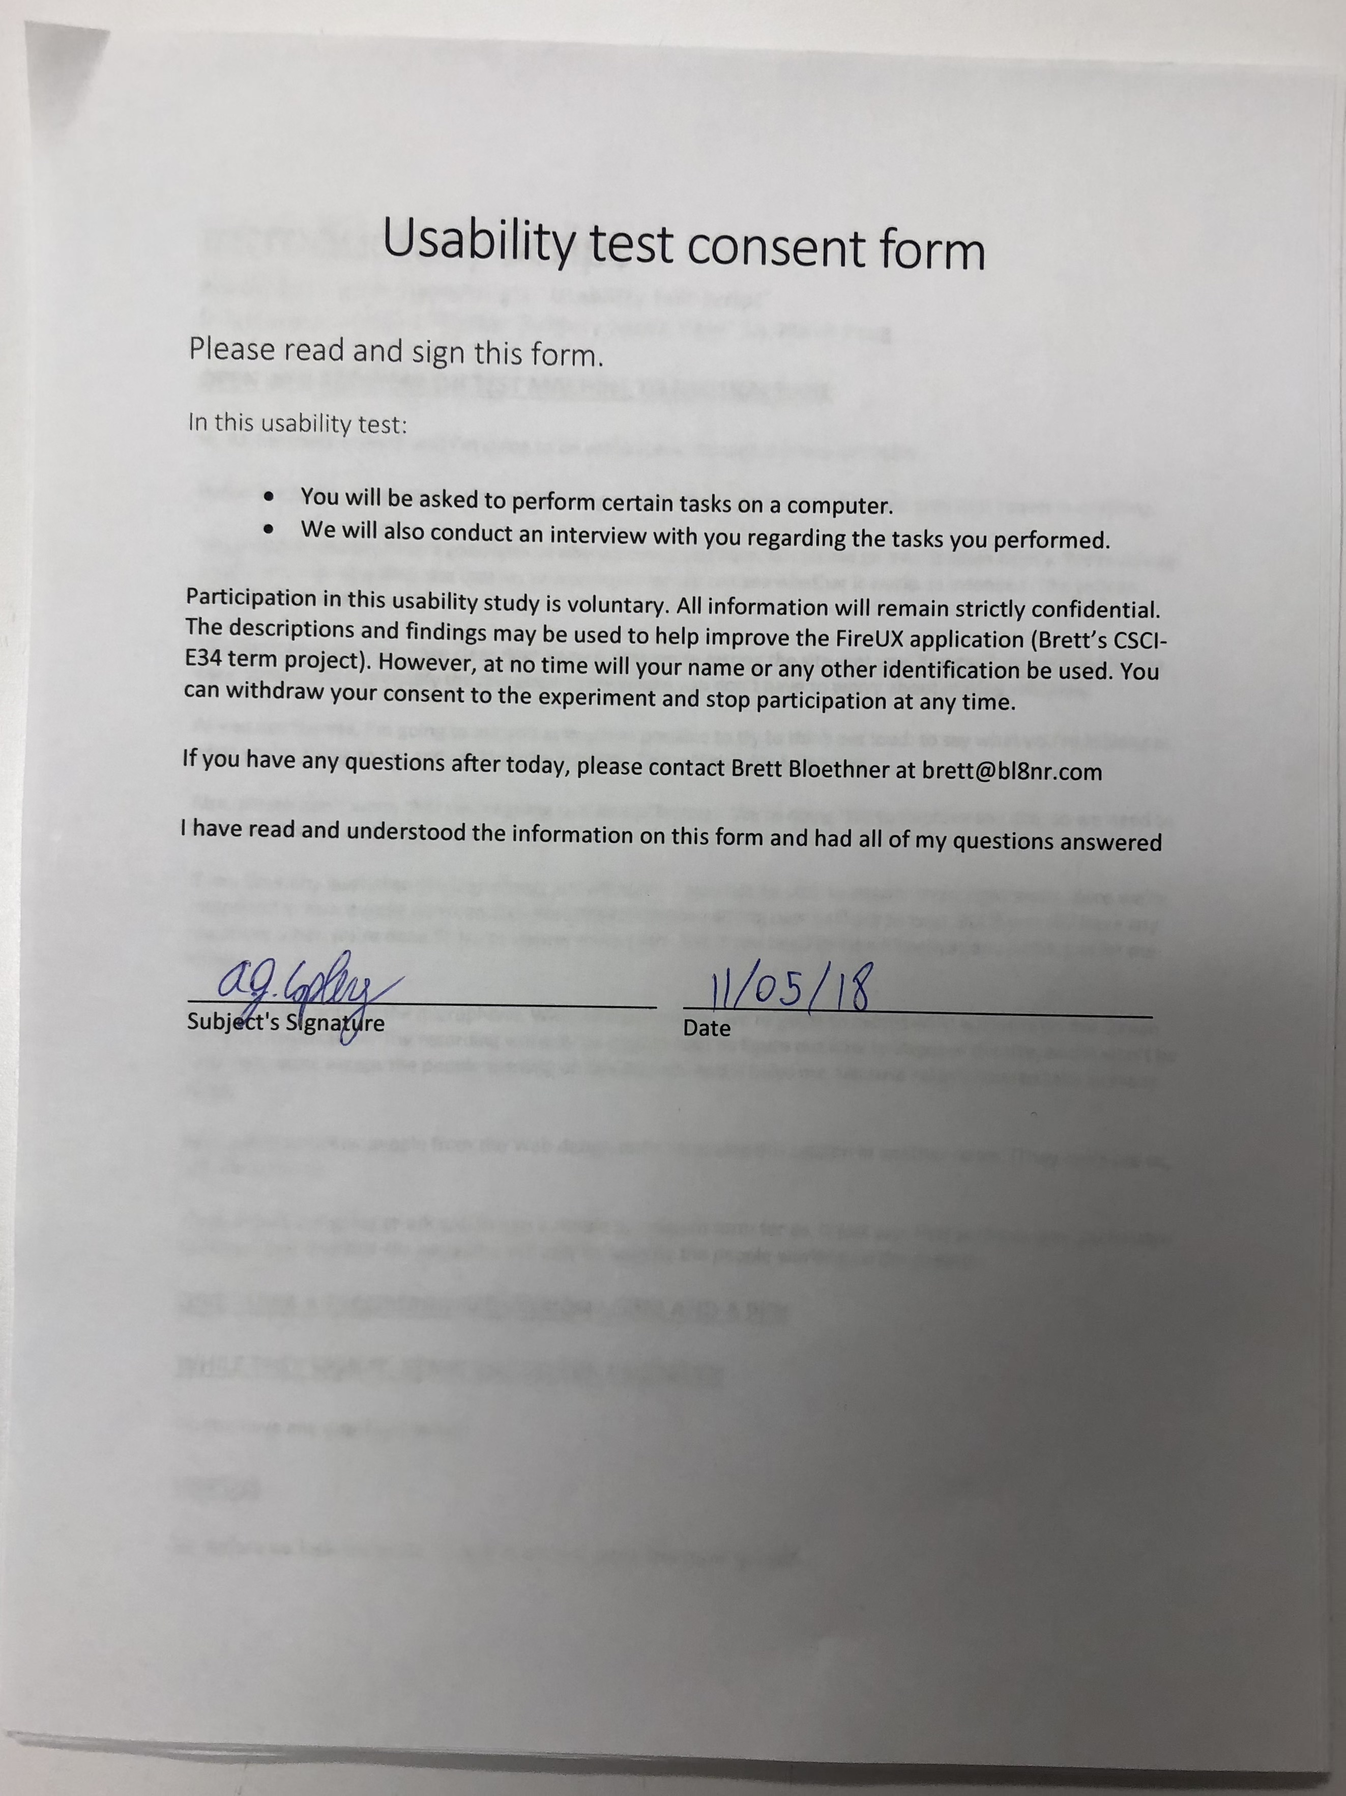

Signed Usability Test Consent Form

User testing started right after AJ completed the Usability Test Consent Form. Overall, AJ had a pretty easy time accomplishing the tasks outlined in section one. A few things of note were that AJ did have trouble determining what the icon-only style buttons represented and as a result, had trouble assuming what they did and when they should be used. This proved to be a substantial issue in storyboard 2 when AJ was asked to add notes to a mockup. This made pretty apparent that the decision to use icons rather than labeled buttons led to a less intuitive interface in both storyboards.

AJ never seemed very anxious or confused while using the prototype. Our discussion at the end of the user testing session made it pretty obvious that AJ preferred storyboard two over storyboard one in all respects except for the unlabeled icon buttons. Otherwise, AJ felt that storyboard two was overall easy to use and intuitive.

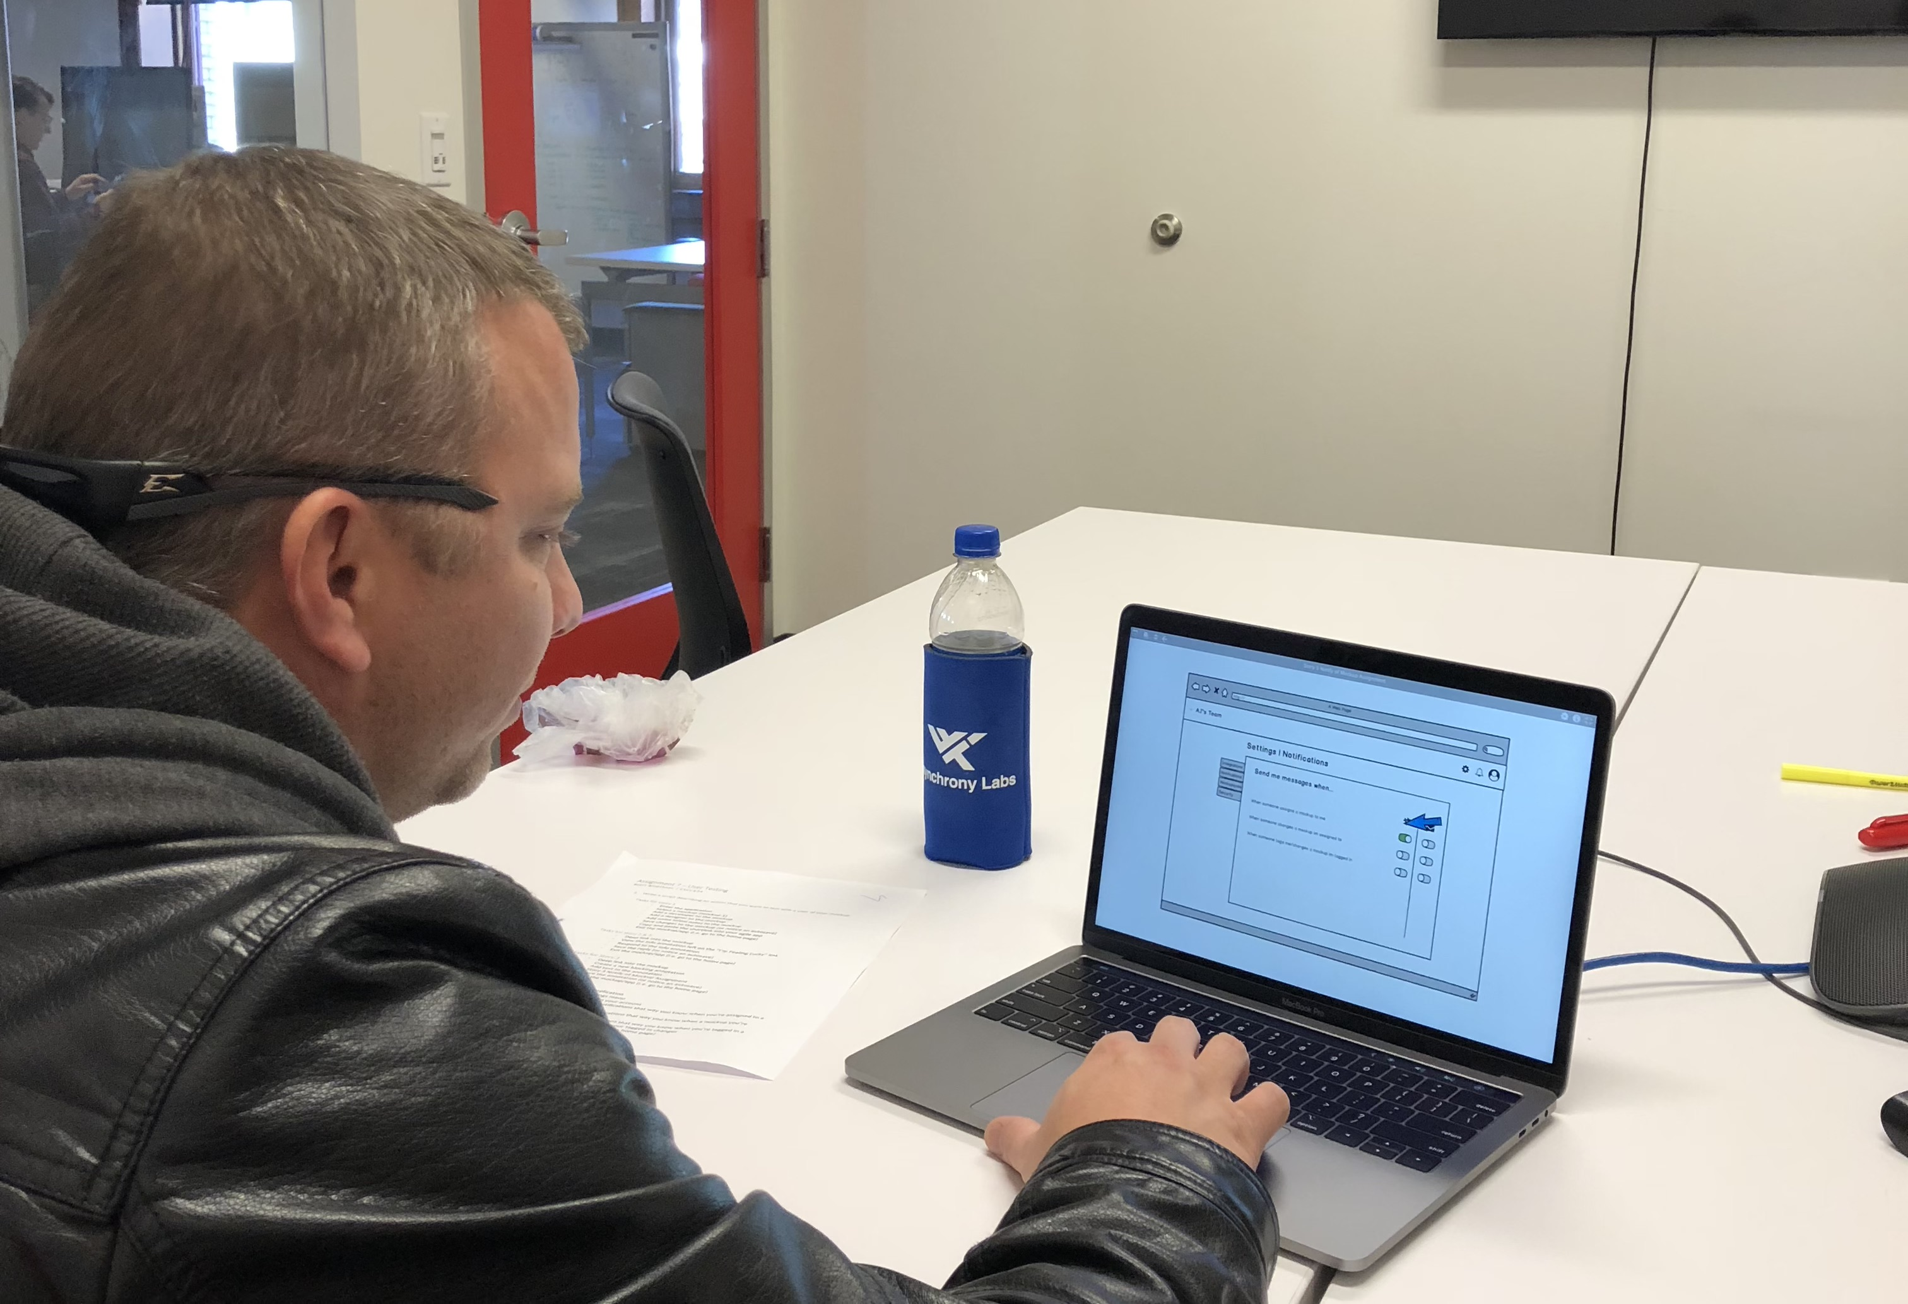

### After the test session, perform a quick debriefing.

**Debriefing questions and answers**

* How did you feel about the unlabeled buttons used to create new annotations?
  + There was major uncertainty about what it was those buttons did
  + User’s assumption that the exclamation point icon button created a new blocker/blocking annotation was correct. However, he seemed uncertain when making this assumption.
  + Users assumption about the info icon button was incorrect. He thought this button would lead to an info pane with a place to edit things such as mockup notes.
  + User had no idea what the paragraph icon button did. The user was eventually able to figure out that it revealed a “mockup notes” popover that he needed for his tasks. However, this happened entirely by chance.
* Did you feel limited by only having two levels of communication (info and blocker)?
  + User didn’t see any limitations in having only info annotation and blocker annotations with which he could point things out on the mockup.
  + User thought there wasn’t enough consideration put into the importance of blocking annotations and how important they may be to the user due to their impact on work in progress.
* Did either of the mockups feel intuitive?
  + User felt like storyboard two was much more intuitive than storyboard one
  + User enjoyed the luxury of having the mockup on a larger portion of the screen
  + User liked the popovers and felt their usage came more naturally than the sidebar style in storyboard one
  + The left-hand icon-based buttons weren’t intuitive in either storyboard
  + User thought the settings page being separated into integrations and notifications felt natural
  + User liked being able to edit all of the notification’s settings in one spot whether it’s for Slack or another integration
  + User recommended keeping storyboard two and making modifications to it, rather than taking anything from storyboard one in its entirety
* What changes would you recommend? Is there anything that you thought neither storyboard did well?
  + User thought that blockers weren’t very well represented in the mockups
  + User thought the impact of blockers on work in progress warranted blockers to have a more explicit and apparent element in the application.
  + User also believed that the addition of a blocker should trigger a notification and that these notifications should be configured for all blockers and/or just blockers in mockups the user is involved in

### Formulate and write up a plan describing the changes you would make to the UI based on what this user did. Submit this for your assignment.

* User believed the button with the “info” icon on it opened up a mockup info window that included the notes section
  + **Change:** Keep this button as one of the few default buttons still on the mockup area. Make it so that it views a popover where the user can edit mockup info and mockup notes like he expected.
  + **Change:** Move the button’s current functionality of “new info annotation” to a labeled button in the taskbar directly above the mockup view window.
* Storyboard one didn’t seem intuitive compared to storyboard two
  + **Decision:** Move forward with storyboard two and make modifications to it to optimize its user experience according to our user interviews
* Storyboard one’s sidebar-based design wasn’t intuitive
  + **Change:** Move forward with the popovers in storyboard two and give preference to popovers in the mockup view page design when the option arises. Right now, storyboard two is primarily popover based.
* User wasn’t confident in what the action of the exclamation point icon button was and he was unsure of how to create a blocking annotation
  + **Change:** Move the “new blocking annotation” functionality to a labeled button in the taskbar directly above the mockup view window, similar to the change done to the “new info annotation” function.
  + **Change:** Remove the exclamation point icon button entirely
* User felt that too many icons with similar looks got confusing.
  + The changes for the “new info annotation” and “new blocking annotation” functions should fix this issue by minimizing the number of non-user generated icon buttons on the mockup to only three (mockup info, mockup short link, delete mockup).
  + **Change:** Remove the question mark icon button that would have otherwise been used to let the user get help (help docs, application tips, etc…)
* User felt that blockers/blocking annotations weren’t given enough importance in the application
  + **Change:** Add a slim notification bar to the top of the window that shows when there is an unresolved blocking annotation on the mockup currently being viewed.
* User felt that they should have options to be notified specifically of changes related to blockers
  + **Change:** Add an option in the notifications page to let the user be notified when a blocker related change occurs on any mockup
  + **Change:** Add an option to the notifications page to let the user be notified when a blocker related change occurs on a mockup they’re involved with (they’re assigned to or tagged in)
* User felt the settings page having its own section to setup integrations (for Slack) was intuitive despite not having the actual notifications configured there and rather revealing a link to the notifications section
  + **Decision:** Move forward with storyboard 2s implementation of the Slack integration setup
* User felt the settings page having its own section to configure notifications for all integrations in column form was intuitive and easier to user since it allowed for all notifications to be configured in one spot.
  + **Decision:** Move forward with storyboard 2s implementation of the notification’s configuration page

### Some ending notes, reflection.

Mr. Platt wasn’t kidding when he said he was sure we would be surprised by some of what we discover in our user testing. I anticipated storyboard one to come out on top during the user testing but not only did it fail to do that, it was specifically not recommended against storyboard two. This was a pretty critical revelation for me since I very well could have moved forward with storyboard one rather than storyboard two had I never conducted any user testing. I think the most surprising discovery was that the settings page design in storyboard two felt more natural to AJ than in storyboard one. I had trouble coming up with two equally unique designs for the settings pages in each storyboard. Admittedly, the settings page in storyboard two was a much less thought-out design of mine that I sort of tossed in there to diversify the two storyboards against each other. I was legitimately surprised when AJ mentioned the settings page in storyboard two, with notifications and integrations split into their own separate pages, felt more intuitive and natural to him. I can definitely see the value in quality user testing now.

Usability test consent form

# Please read and sign this form.

## In this usability test:

* **You will be asked to perform certain tasks on a computer.**
* **We will also conduct an interview with you regarding the tasks you performed.**

Participation in this usability study is voluntary. All information will remain strictly confidential. The descriptions and findings may be used to help improve the FireUX application (Brett’s CSCI-E34 term project). However, at no time will your name or any other identification be used. You can withdraw your consent to the experiment and stop participation at any time.

If you have any questions after today, please contact Brett Bloethner at brett@bl8nr.com

I have read and understood the information on this form and had all of my questions answered

|  |  |
| --- | --- |
| _____________________________________ | _____________________________________ |
| Subject's Signature | Date |

Introductory Script

Repurposed from Steve Krug’s “Usability test script”

Originally printed in “Rocket Surgery Made Easy” by Steve Krug

**OPEN WEB BROWSER ON TEST MACHINE TO NEUTRAL PAGE**

Hi, AJ. My name is Brett, and I’m going to be walking you through this session today.

Before we begin, I have some information for you, and I’m going to read it to make sure that I cover everything.

You probably already have a good idea of why we asked you here, but let me go over it again briefly. We’re asking people to try using a Web site that we’re working on so we can see whether it works as intended. The session should take about an hour.

The first thing I want to make clear right away is that we’re testing the site, not you. You can’t do anything wrong here. In fact, this is probably the one place today where you don’t have to worry about making mistakes.

As you use the site, I’m going to ask you as much as possible to try to think out loud: to say what you’re looking at, what you’re trying to do, and what you’re thinking. This will be a big help to us.

Also, please don’t worry that you’re going to hurt our feelings. We’re doing this to improve the site, so we need to hear your honest reactions.

If you have any questions as we go along, just ask them. I may not be able to answer them right away, since we’re interested in how people do when they don’t have someone sitting next to them to help. But if you still have any questions when we’re done I’ll try to answer them then. And if you need to take a break at any point, just let me know.

With your permission, we’re going to record what happens on the screen and our conversation. The recording will only be used to help us figure out how to improve the site, and it won’t be seen by anyone except the people working on this project. And it helps me, because I don’t have to take as many notes.

If you would, I’m going to ask you to sign a simple permission form for us. It just says that we have your permission to record you, and that the recording will only be seen by the people working on the project.

**GIVE THEM A RECORDING PERMISSION FORM AND A PEN**

**WHILE THEY SIGN IT, START THE SCREEN RECORDER**

Do you have any questions so far?

**DISCUSS**

OK. First I’d like to ask you just a few quick questions.

First, what’s your occupation? What do you do all day?

**DISCUSS**

On a scale of one to ten, how expert would you consider yourself with computers?

**DISCUSS**

OK, great. We’re done with the questions, and we can start looking at things.

Thanks. Now I’m going to ask you to try doing some specific tasks. I’m going to read each one out loud and give you a printed copy. And again, as much as possible, it will help us if you can try to think out loud as you go along.

**ADLIB THROUGH THE TASKS/TASK SHEET IF NEED BE**

Thanks. Do you have any questions for me, now that we’re done?